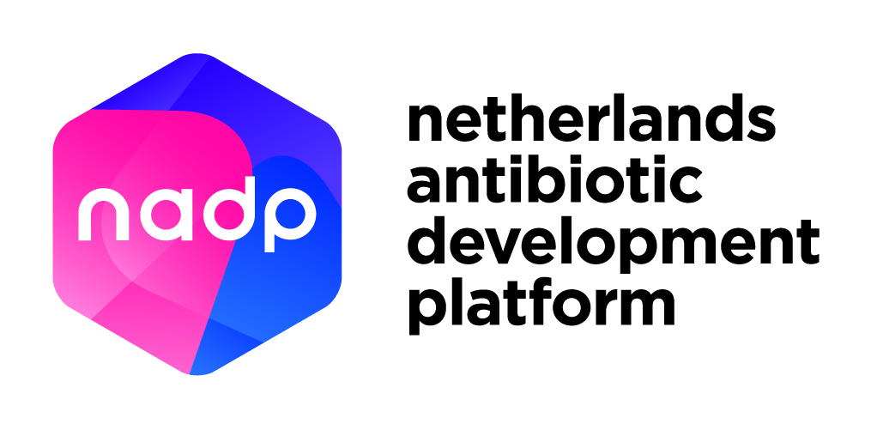
NADP Lead Development Voucher template

Project title:

_____________

This application should not exceed 8 pages (A4 format), excluding the front page, table of contents, and appendices.

For more information about NADP Vouchers, please refer to the document “Guidelines and conditions for NADP Vouchers applications” or contact: vouchers@nadp.nl.

NADP Lead Development Voucher template
Non-confidential application

1. Contact details and summary

Applicant

Main applicant
Name of organisation :
Department :
Name of contact person :
Position :
Correspondence address :
Telephone :
E-mail :
Organisation type :
(Company / University / University medical centre / Applied sciences institute / Institute / Other)
SME (MKB) : Yes / No
URL of (personal) web page :
(Scientific) excellence and expertise of the main applicant and added value of the main applicant to the quality of the project :

Benefit of this project for the main applicant:

Please provide the IBAN information of the main applicant’s organisation to facilitate the payment of the subsidy.
IBAN :
To the name of :
Payment Reference you like us to use:
Other required characteristics :

For SMEs only:
Chamber of Commerce no. :
Year of registration :
Relation between SME applicant and co-applicants:
If applicable, please indicate to which extend there is a professional relation between SME and co-applicants (Max. 150 words)

Shareholder structure:
If applicable, brief description of the shareholder structure, shareholders, and shares
(Max. 150 words)

Co-applicant (if applicable)
Name of organisation :
Department :
Name of contact person :
Position :
Correspondence address :
Telephone :
E-mail :
Organisation type : (Company / university / university medical centre / institute / other)
SME (MKB) : Yes / No
URL of (personal) web page :
(Scientific) excellence and expertise of the co-applicant and added value of the main applicant to the quality of the project :
Benefit of this project for the co-applicant:

Service supplier
Name of organisation :
Name of contact person :
Position :
Correspondence address :
Telephone :
E-mail :
Telephone :
URL of (personal) web page :
Chamber of Commerce no. :

Please note that the applicant and service supplier should be different entities.

Relation between applicant(s) and service supplier:
If applicable, describe if there are shares, interests, or formal relations between applicant and service supplier (Max. 150 words)

1.3 Project application summary
(This public summary (in English) should be suitable for publication; please consider any risks to intellectual property/business strategy. Max. 200 words)

2. Background
(max. 3 pages, A4 format)

2.1 Introduction

Describe the research topic (background). (Max. 200 words)

2.2 Scientific foundations of new antibiotic / alternative lead

Describe how this lead fits in the strategic focus areas of the NADP Research and Development Agenda (RDA). Specify the class of drugs (small molecule, biological, other). (Max. 300 words)

2.3 Current state of lead development
Describe the scientific research and information obtained about the lead compound so far. Describe the current phase of development of the project (hit to lead, lead optimisation, or pre-clinical development). Indicate the target species involved, already available data, and how the state of development fits within the minimal entry thresholds. (Max. 300 words)

2.4 Lead target pathogens

Clearly mark the pathogens targeted by/that will be targeted by the lead developed under this project

☐ Acinetobacter baumannii
☐ Pseudomonas aeruginosa
☐ Enterobacteriaceae
☐ Klebsiella pneumoniae
☐ Enterococcus faecium
☐ Staphylococcus aureus
☐ Helicobacter pylori
☐ Campylobacter spp.
☐ Salmonellae
☐ Neisseria gonorrhoeae
☐ Streptococcus pneumoniae
☐ Haemophilus influenzae
☐ Shigella spp.
☐ Clostridium difficile
☐ Streptococcus pneumoniae
☐ Mycobacterium tuberculosis
☐ Other. Please specify:

2.5 Required upcoming step(s)
Clearly describe the next steps needed for the lead development process and indicate what has already been done to identify these steps. State whether a current product development plan is available. State whether an NADP Value Proposition Voucher has been requested/used. (Max. 300 words)

2.6 Describe additional steps needed to move on to clinical studies
Describe the additional steps needed to bring the lead compound in the first clinical study. Please include a timeline and budget estimation. (Max. 200 words)

2.7 Target indication(s), approximate population, societal impact, and commercial opportunity
Indicate the possible economic and societal relevance and impact of the new lead. Describe alternatives that currently exist or are under development, which companies or organisations are working on them, and what advantages this lead will offer. Describe the eventual earning model. (Max. 300 words)

2.8 Intellectual Property position
Describe how intellectual property is arranged. Include at least the following information: 1) patent title(s), 2) inventor(s), 3) patent number(s), 4) if unpublished, state the claim. (Max. 250 words)

3. Project plan description
(max. 3 pages, A4 format)

3.1 Purpose of the project
Describe the project objectives. (Max. 500 words)

3.2 Activities in the project
Describe which activities will be conducted within the project and by whom. (Max. 400 words)

3.3 Time frame
Describe the time frame for this project. (Max. 200 words)

3.4 Expected deliverables
Indicate what will be delivered upon the completion of the project. A deliverable is a distinct output of the project, meaningful in terms of the project's overall objectives, and constituted by a report, a document, a technical diagram etc. (Max. 300 words)

3.5 Risks of the project deliverables
Describe any critical risks (technical and/or financial) relating to the project’s success and briefly detail the risk mitigation measures. (Max. 200 words)

4. Budget plan

4.1 Requested budget and budget specification
Clearly state the budget amount requested for the complete project (max. € 50.000,-). Provide a specification of the project budget. Please specify the costs of the service supplier (include a quotation as appendix) and the costs for the applicant. All costs of third parties, including the service provider, must be provided including value-added tax (VAT). Please specify the in-kind contribution of the applicant. (Max. 400 words)

4.2 Budget justification
Explain why you need external funding for this project. Describe why existing resources, for instance your Technology Transfer Office, own financial resources or in-house capabilities, are limited for this project. (Max. 200 words)

5. Applicant statement
Have you requested funding for the same or similar projects with other organisations or financiers? | ☐ No  ☐ Yes

If yes, please provide details, including which funding/grant, funding organisation and size of funding. (Max. 200 words):

The following documents must be submitted together with the application:
- Short curriculum vitae of the main applicant (max. 1 A4);
- List of most relevant publications (max. 4 from last 3 years; if applicable);
- Relevant quotation(s);
- List of patents/key conclusions of patentability and Freedom-to-Operate (if applicable);

I agree that this application will be reviewed by independent expert(s) appointed by the NADP Executive Board and that this application is considered non-confidential.

I hereby declare that I have filled in this form to the best of my knowledge.

Place and date:

Name:

Signature:

Applications should be submitted to vouchers@nadp.nl with the title “Non-confidential application for NADP Vouchers”.

