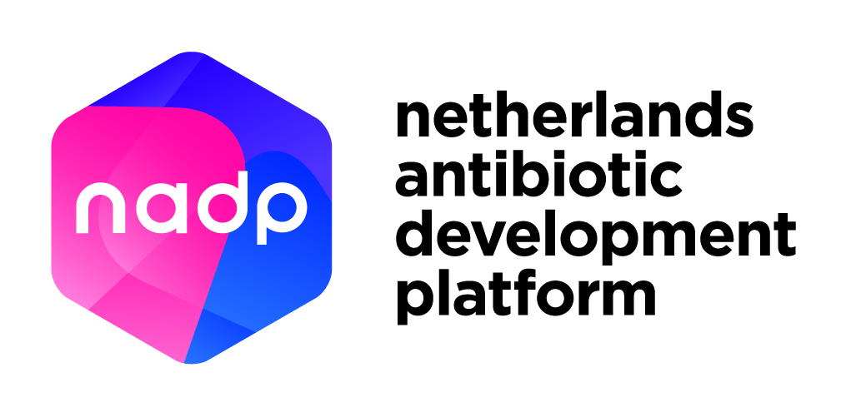
NADP Intellectual Property Voucher and Value Proposition Voucher template

Project title:

_____________

This application should not exceed 8 pages (A4 format), excluding the front page, table of contents, and appendices.
For more information about NADP Vouchers, please refer to the document “Guidelines and conditions for NADP Vouchers applications” or contact: vouchers@nadp.nl.

NADP Intellectual Property Voucher and Value Proposition Voucher template
Non-confidential application
Key requirements (please also refer to the “Guidelines and conditions NADP Vouchers applications” document):
- Organisation must be a knowledge institute or small and medium-sized enterprise (SME) located within the Netherlands.
- Applicant must be an employee of this organisation.
- Applicants can apply for an Intellectual Property Voucher or a Value Proposition Voucher, or a combination of both.
- Applications must involve a lead that is a novel antibiotic or alternative therapeutic for the treatment of bacterial infections, as described in the NADP Research & Development Agenda (https://nadp.nl/nadp-vouchers/). Preventatives, diagnostic tools, (medication) delivery devices, new formulations of existing therapeutics, and enabling technologies will not be considered.
- Applications must target at least one pathogen from the WHO priority pathogens list for R&D of new antibiotics (http://www.who.int/mediacentre/news/releases/2017/bacteria-antibiotics-needed/en/). Additional pathogens considered here include Clostridium difficile, Streptococcus pneumonia, and Mycobacterium tuberculosis.

Applicant information

Name
Position
E-mail
Phone number
Visiting address
Postal address
Organisation name
Legal state of organisation | ☐ University or university medical centre  ☐ University of Applied Sciences (“hogeschool”)  ☐ Scientific Institute  ☐ SME (Please complete the online test to determine if your organisation classifies as an SME: https://www.rvo.nl/subsidies-regelingen/subsidiespelregels/aanvraag-indienen/mkb-toets  or directly go to https://flt.uwe.be/)
Main shareholders
(if applicable)
Applicant applies for | ☐ Intellectual Property Voucher (max. €5.000)  ☐ Value Proposition Voucher (max. €15.000)
Requested funding (in €)

Project description

General explanation of the invention (200 words maximum)
Targeted indication(s) and approximate patient population (200 words maximum)
Class of drug | ☐ Small molecule. Specify:  ☐ Biological. Specify:  ☐ Other. Specify:
Targeted pathogens | ☐ Acinetobacter baumannii  ☐ Pseudomonas aeruginosa  ☐ Enterobacteriaceae  ☐ Klebsiella pneumoniae  ☐ Enterococcus faecium  ☐ Staphylococcus aureus  ☐ Helicobacter pylori  ☐ Campylobacter spp.  ☐ Salmonellae  ☐ Neisseria gonorrhoeae  ☐ Streptococcus pneumoniae  ☐ Haemophilus influenzae  ☐ Shigella spp.  ☐ Clostridium difficile  ☐ Streptococcus pneumoniae  ☐ Mycobacterium tuberculosis  ☐ Other. Please specify:
Route of administration: intravenous / oral / inhaled / topical / other
Please explain (100 words maximum)
Current stage of development | ☐ Hit to lead  ☐ Lead optimization  ☐ Preclinical development
Specify data already available. Please refer to the document information on minimal requirements for the provided values. | ☐ MIC values  ☐ Mechanism of action  ☐ in vitro efficacy data  ☐ In vitro ADME/DMPK data  ☐ In vivo efficacy data  ☐ In vivo ADME/DMPK data  ☐ In vivo safety data  ☐ Other. Please specify (do not share confidential data):
Has a novelty analysis been performed? Please specify
(100 words maximum)
Is IP available? Who is the owner of the IP?
Please include a list of patents and key conclusions of patentability and freedom-to-operate (if applicable).(200 words maximum)
Is an up-to-date plan available describing all steps needed to proceed to Phase X of clinical evaluation? (If yes, describe in max 200 words, include timelines and budget estimation)
Please include a list of the key academic / industrial partners involved (if applicable).
Have you requested and/or received funding for this antibiotic/ alternative lead(s)? If yes, please include details on grant, funding organisation and size of funding (250 words maximum).
Have you signed any partnership deals (e.g. biopharma company) for any of your antibiotic programs? If yes, please list.
Explain why existing resources are limited for this project.(100 words maximum) | (explain why resources, for instance your Technology Transfer Office, own financial resources or in-house capabilities are not available/limited for this project)
Project application summary (200 words maximum) | (This English-language public summary should be suitable for publication; please consider any risks to intellectual property/business strategy)

For application of an Intellectual Property Voucher

Describe the specific activities for which funding is requested (200 words maximum).
Which independent organisation will you consult for these activities? Please add a quotation of this organisation as an attachment.
Describe and specify your own in-cash or in-kind contribution to this project. (eligible in-kind co-funding: man-hours).
What are the planned starting and ending dates of the project?

Project costs
A | Costs of applicant (without VAT) | €
B | Costs of service provider (with VAT) | €
C (=A+B) | Total project costs | €

Project funding
D | In-cash contribution of applicant (with VAT) | €
E | In-kind contribution of applicant (without VAT) | €
F | Requested funding (value of Voucher) | €
G (=D+E+F) | Total project funding | €

Please note that the total project costs should be equal to the total project funding (C should equal G).
Please note that up to 75% of the total project funding can be covered by the requested funding (value of Voucher). This means F is max 75% of G.

For application of a Value Proposition Voucher

Describe the specific activities for which funding is applied (max. 200 words).
Which organisation do you want to consult for these activities? Please add a quotation of this organisation as an attachment.
Relation between applicant(s) and service supplier(max. 150 words) | (If applicable, describe if there are shares, interests, or formal relations between the applicant and service supplier)
Describe your own in-cash or in-kind contribution to this project. (eligible in kind co-funding: man-hours).
What are the planned starting and ending dates of the project?

Financial overview
Please fill in the following project cost and project funding scheme.
Overall project costs
A | Costs of applicant (without VAT) | €
B | Costs of service provider (with VAT) | €
C (=A+B) | Total project costs | €

Overall project funding
D | In-cash contribution of applicant (with VAT)? | €
E | In-kind contribution of applicant (without VAT) | €
F | Requested funding (value of Voucher) | €
G (=D+E+F) | Total project funding | €

Please note that the total project costs should equal the total project funding (C should equal G).
Please note that up to 75% of the total project funding can be covered by the requested funding (value of Voucher). This means F is not more than 75% of G.

In addition to this template, the following non-confidential documents must be submitted with the application:
- Short curriculum vitae of the main applicant (max. 1 A4);
- List of most relevant publications (max. 4 from last 3 years; if applicable);
- Relevant quotation(s);

I agree that this application will be reviewed by an independent expert appointed by the NADP Executive Board and that this application is considered non-confidential.
I hereby declare that I have filled in this form to the best of my knowledge.
Place and date:
Name:
Signature:

Applications should be submitted to vouchers@nadp.nl with the title “Non-confidential application for NADP Vouchers”.

